Project description

Name of student

Name of professor

University

Course

Date

**Introduction**

The applications main objective is to help curb insecurity within the estates, this shall be done by ensuring that the tenants or local residents within the estate each connect to each other using the application main reporting features. The applications connects the main areas of the estate that are prone to insecurity and then alerts the residents in those areas of the potential security threats posed in those areas and the residents are able to take necessary actions to curb the insecurity issues.

The application is targeted for residential owners, tenants and partners of these residential estates wherever they are located. The objective of the application is to highlight the insecurity risks that are rampant in these regions, raise alarm to local residents so that the necessary authorities can take the necessary actions and curb the insecurity threats in these places.

The applications main revenue model is based on the subscription model, each and every estate user has to pay a monthly or an yearly amount in order of access the applications main features to use the applications, registration in the application is free but in order to submit a case via the application, the user must subscribe to a specific plan within the application.

I come in as both the developer and the data analyst for this particular application.

**Business Analytics**

The following are some of the users of this product/application

Tenants;

These are families who reside in the estate neighborhoods, they may be individual household members or the whole family members.

Partners;

These include the security arms of both the private and the public entities.

Real estate owners and developers

These are the personals who manage the estate residential places for each and every tenant family.

**Business rules to be used:**

From a data modeling and designing perspectives certain business rules are going to be enforced based on the below database class objects:

* Tenants
* Crime
* Partners
* Estate
* Region
* House

The following database rules shall apply:

1. ONE tenant can ONLY belong to ONE estate
2. MANY tenant can submit MANY cases
3. MANY regions can have MANY estates
4. ONE crime can only have ONE tenant
5. ONE house can have MANY tenants
6. MANY crimes can have MANY houses
7. ONE partner can belong to MANY regions

Based on the above business rules and logic, the estate security application shall have the following tables:

1. Tenants table
2. Partners table
3. Regions table
4. Houses table
5. Crimes table
6. Estates table

**Entity relationship diagram:**

The below entities relationship diagram is associated with the above table objects.

The primary key (PK) which is the ID one table become the secondary key Foreign key (FK) in the other table.

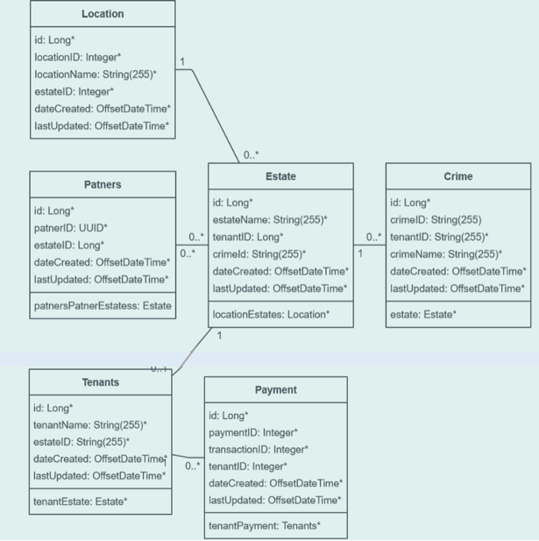

**Database implementation**

**The database story:**

The user’s first interaction with the application sees them open the application and register. During the registration process, the user has the option of offering a onetime payment off, a monthly payment or an annual subscription model. From there, based on the role type that user chose during registration, they are directed to the necessary page where they need to choose the necessary action to complete the process activity. If it’s a tenant, they can chose to submit a particular crime or report a suspicious alert of a crime within the neighborhood. Later they can check the status of their reports and get feedback.

**The associated SQL commands;**

-- Get all history of all crimes

SELECT * FROM CRIMES

--ALL SUSPECT CRIMES AS

SELECT a.*, b.* FROM CRIMES a

LEFT OUTER JOIN PERSONS b

ON a.PERSON_ID = b.PERSON_ID

--LATEST CRIMES

SELECT * FROM CRIMES WHERE CRIME_TIMESTAMP >= '2022-02-22'--LATEST CRIMES

--LATEST CRIMES

SELECT * FROM CRIMES WHERE CRIME_TIMESTAMP >= '2022-02-22'

AND CRIME_LOCATION = 'ORLEANS'

--ASSOCIATE CRIME TO PERPETRATOR

SELECT a.*, b.*,c.FINGERPRINT_ID FROM CRIMES a

LEFT OUTER JOIN PERSONS b

ON a.PERSON_ID = b.PERSON_ID

LEFT OUTER JOIN BIO

ON b.PERSON_ID = c.PERSON_ID

select * from crimes

where crime_location = 'Woodvale'

and crime_status = 'not solved'

and crime_timestamp >='2017-01-01'

**Analytics, reports and metrics**

For the business decision making process, certain key areas of reporting would be crucial, they include the following:

* The trend of crimes in these areas
* Crime leading areas
* Most dominating crimes
* Features of highly targeted crime hotspots

The graph below is a summary of the total number of population members targeted across the years with all manner of possible crimes. The targeted population has been increasing, so has been the number of crimes.

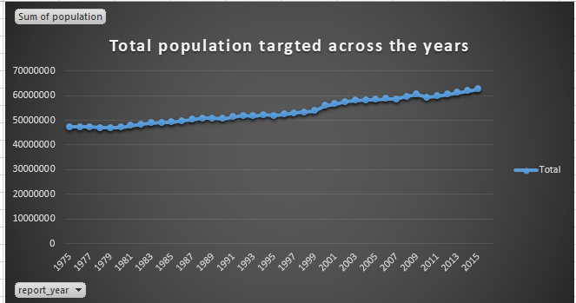

**Security concerns**

The data will be stored in a cloud server. The only concern with this type of storage is that the same cloud service is also used by other clients and so privacy of information is not a final deal. We run the risk of exposure of our data to other users who might have exploited vulnerabilities of these cloud services. The solution is to have an in-house managed server.

**Architecture**

The solution will be available within an internal server hosted application, since we do not target several millions of users, so the internally hosted application is easier to maintain and scale on agile.

Learning and outcomes

During this course, I have learned the following important skills;

* Innovative business products
* Design of technical solutions to solve business problems
* Simple to complex data design based on database objects, classes and attributes
* Querying and solving problems using SQL language
* Scaling applications to meet business needs.

**References**

Wiederhold, G. (1983). *Database design* (Vol. 1077). New York: McGraw-Hill.

Powell, G. (2006). *Beginning database design*. John Wiley & Sons

Kachaner, N., Lindgardt, Z., & Michael, D. (2011). Innovating low‐cost business models. *Strategy & Leadership*.

Bertino, E., & Sandhu, R. (2005). Database security-concepts, approaches, and challenges. *IEEE Transactions on Dependable and secure computing*, *2*(1), 2-19.